Arthur Liou

CS372

Lab 3

*Notes: I’ve attached my screenshots and boxed in red where I annotated my output.*

1. What is the IP address and TCP port number used by the client computer (source) that is transferring the file to gaia.cs.umass.edu? To answer this question, it’s probably easiest to select an HTTP message and explore the details of the TCP packet used to carry this HTTP message, using the “details of the selected packet header window” (refer to Figure 2 in the “Getting Started with Wireshark” Lab if you’re uncertain about the Wireshark windows.

IP Address/TCP Port number:

192.168.1.102:1161

2. What is the IP address of gaia.cs.umass.edu? On what port number is it sending and receiving TCP segments for this connection?

IP Address/TCP Port Number

128.119.245.12:80

For Q1-2

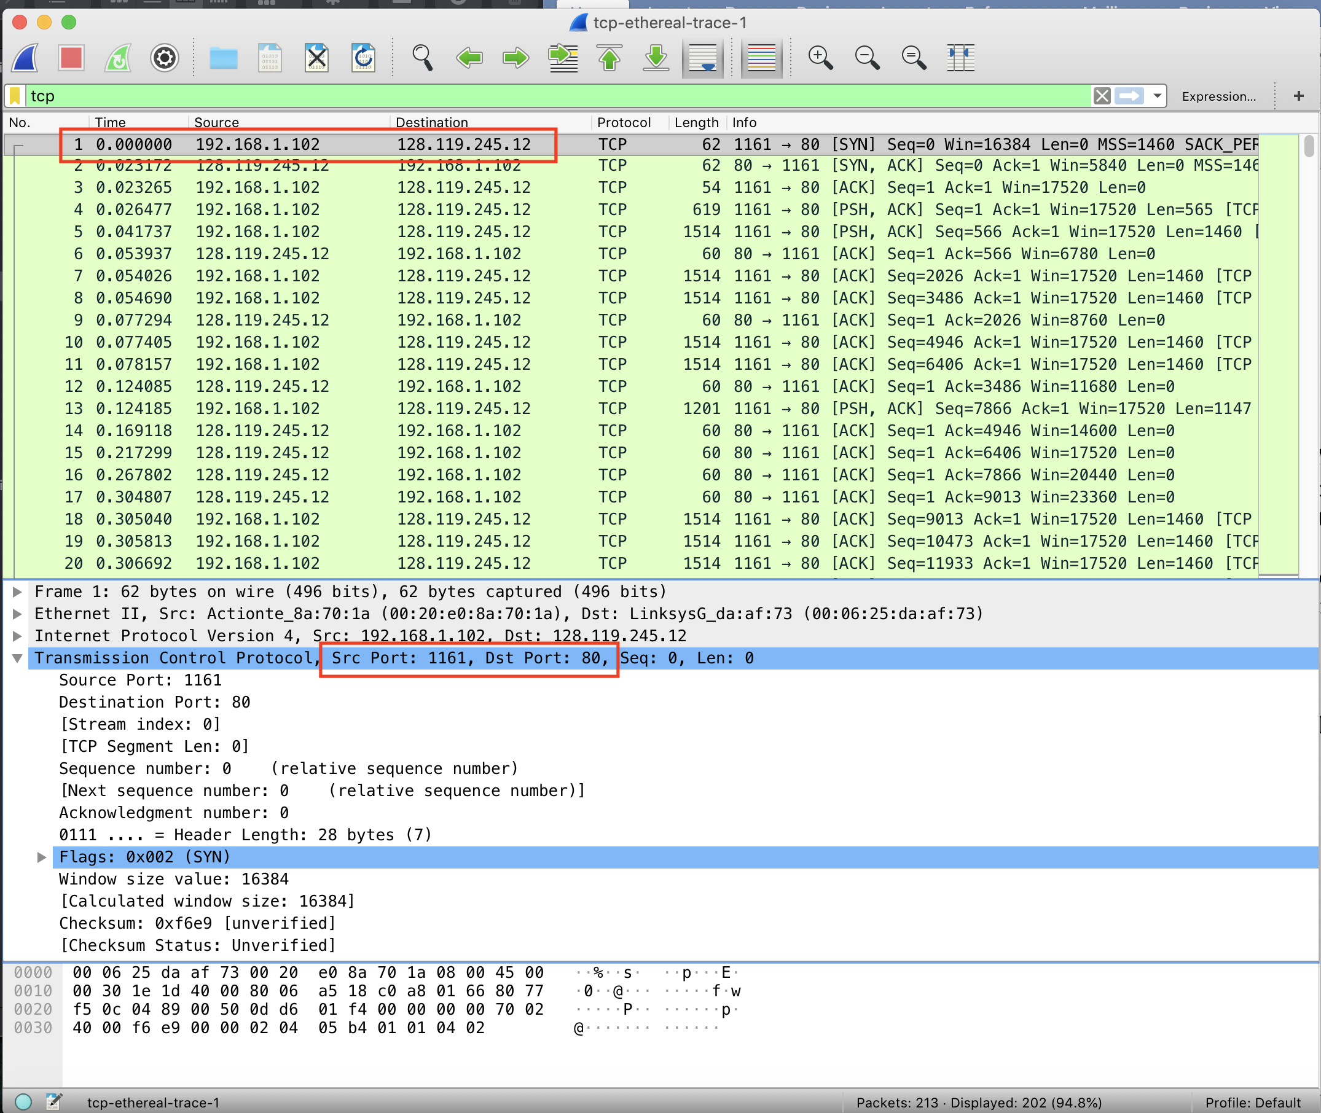

3. What is the IP address and TCP port number used by your client computer (source) to transfer the file to gaia.cs.umass.edu?

172.20.4.134:57151

For Q3

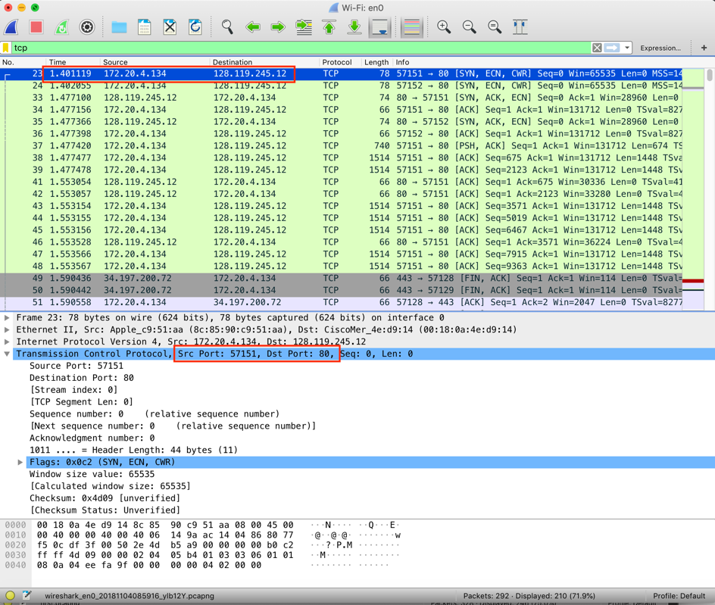

Using tcp-ethereal-trace-1

4. What is the sequence number of the TCP SYN segment that is used to initiate the TCP connection between the client computer and gaia.cs.umass.edu? What is it in the segment that identifies the segment as a SYN segment?

Sequence Number 1. Under Flags, the SYN flag is set to 1/True.

For Q4

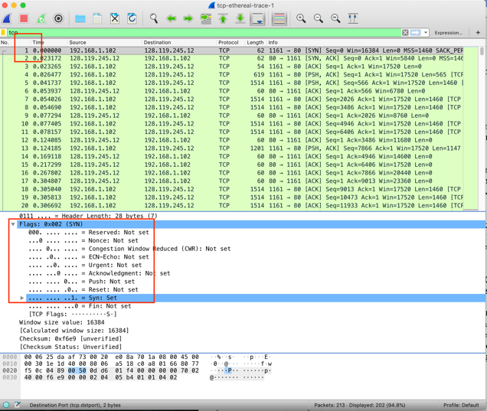

5. What is the sequence number of the SYNACK segment sent by gaia.cs.umass.edu to the client computer in reply to the SYN? What is the value of the Acknowledgement field in the SYNACK segment? How did gaia.cs.umass.edu determine that value? What is it in the segment that identifies the segment as a SYNACK segment?

Sequence Number 2. Value of the Acknowledgement field = 1. Determined by the relative ack number. The Flags for SYN and ACK are set to true.

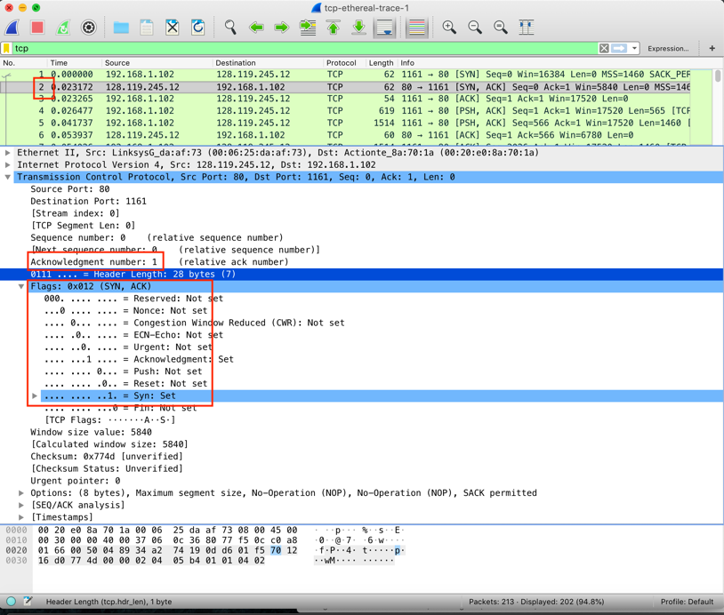

6. What is the sequence number of the TCP segment containing the HTTP POST command? Note that in order to find the POST command, you’ll need to dig into the packet content field at the bottom of the Wireshark window, looking for a segment with a “POST” within its DATA field.

Sequence Number 4

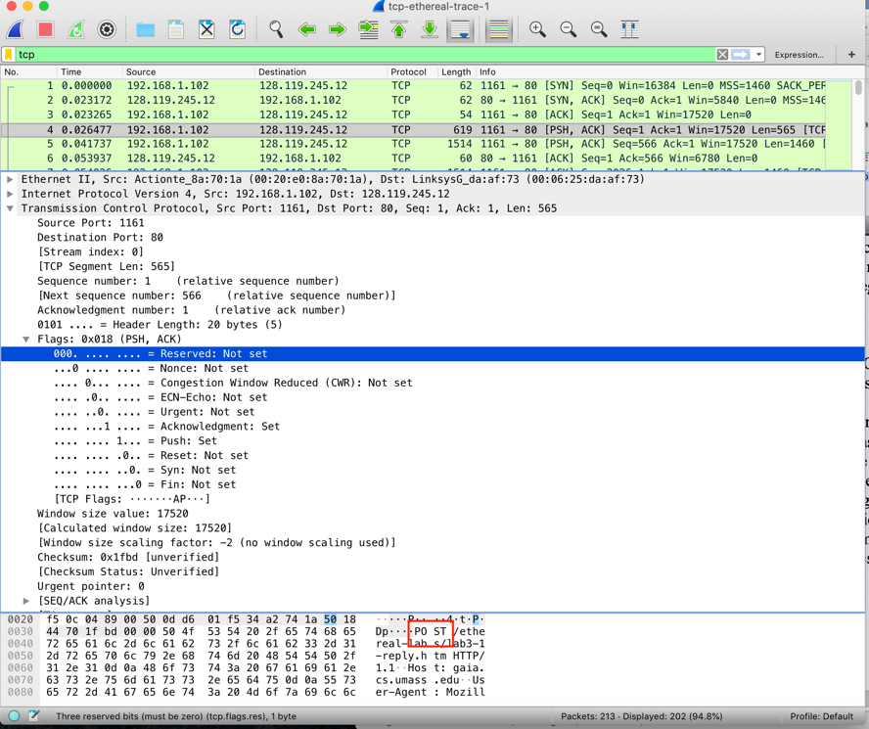

7. Consider the TCP segment containing the HTTP POST as the first segment in the TCP connection. What are the sequence numbers of the first six segments in the TCP connection (including the segment containing the HTTP POST)? At what time was each segment sent? When was the ACK for each segment received? Given the difference between when each TCP segment was sent, and when its acknowledgement was received, what is the RTT value for each of the six segments? What is the EstimatedRTT value (see Section 3.5.3, page 242 in text) after the receipt of each ACK? Assume that the value of the EstimatedRTT is equal to the measured RTT for the first segment, and then is computed using the EstimatedRTT equation on page 242 for all subsequent segments.

First 6 Segments of the TCP Connection

|  |  |  |  |  |  |
| --- | --- | --- | --- | --- | --- |
| Segment Number | Sequences | Time | ACK w/ Time | RTT | Estimated RTT |
| 4 | 1 | 0.026477 | 6, 0.053937 | 0.02746 | 0.02746 |
| 5 | 566 | 0.041737 | 9, 0.077294 | 0.035557 | 0.028595 |
| 7 | 2026 | 0.054026 | 12, 0.124085 | 0.070059 | 0.033777 |
| 8 | 3486 | 0.054690 | 14, 0.169118 | 0.114428 | 0.043859 |
| 10 | 4946 | 0.077405 | 15, 0.217299 | 0.139894 | 0.055863 |
| 11 | 6406 | 0.078157 | 16, 0.267802 | 0.189645 | 0.072586 |

EstimatedRTT = 0.875*EstimatedRTT + 0.125*SampleRTT

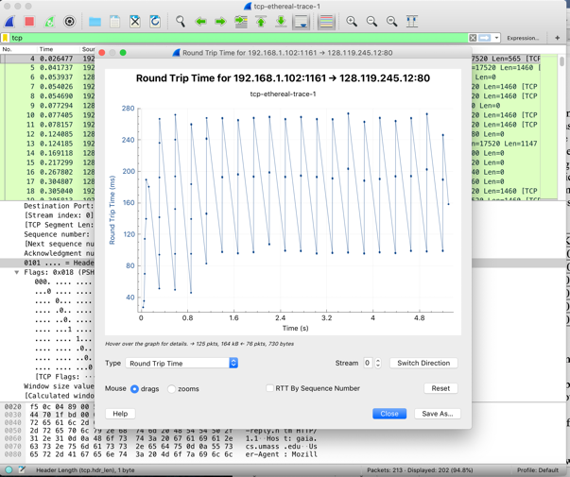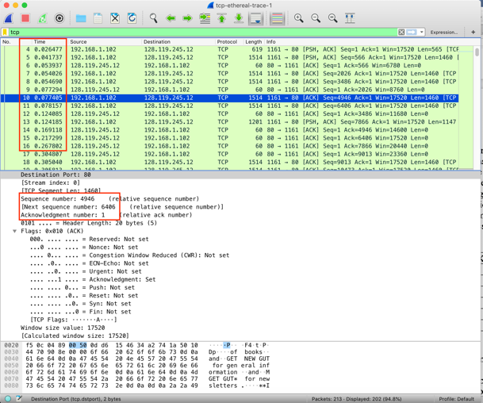

8. What is the length of each of the first six TCP segments?

|  |  |
| --- | --- |
| Number | Length |
| 4 | 565 |
| 5 | 1460 |
| 5 | 1460 |
| 8 | 1460 |
| 10 | 1460 |
| 11 | 1460 |

9. What is the minimum amount of available buffer space advertised at the received for the entire trace? Does the lack of receiver buffer space ever throttle the sender?

Buffer space is 5840 (from first ACK / Segment 2). It will go up to 164091, and no it does not get throttled.

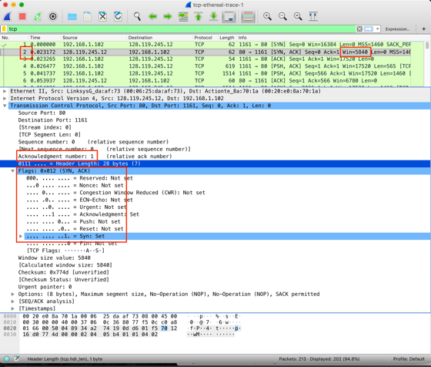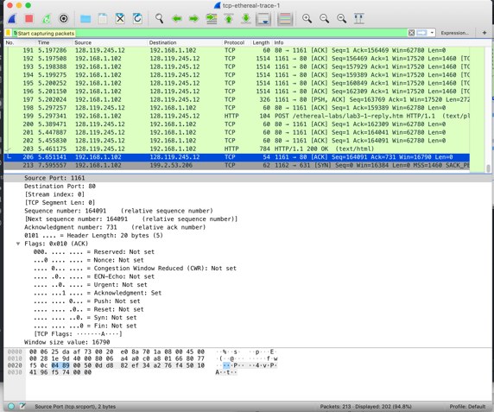

10. Are there any retransmitted segments in the trace file? What did you check for (in the trace) in order to answer this question?

No, I looked at the Sequence Numbers Graph / Time Sequence (Stevens) within Wireshark.

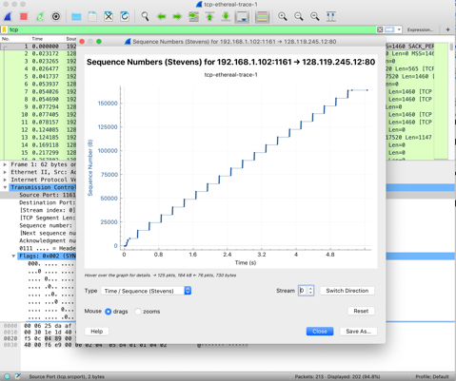

11. How much data does the receiver typically acknowledge in an ACK? Can you identify cases where the receiver is ACKing every other received segment (see Table 3.2 on page 250 in the text).

The receiver acknowledges each segment near the beginning. Then (like in the case below), it starts to acknowledge them in “chunks” and is such in every other received segment

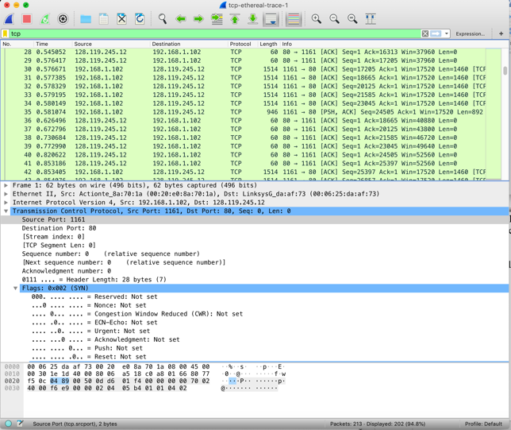

12. What is the throughput (bytes transferred per unit time) for the TCP connection? Explain how you calculated this value.

Throughput = total data / transmission rate.

Total Data = first post to lack ACK sequences. 164091 bytes

Send Time = 5.6511

164091 / 5.6511 = 29037.001645697 = **29.04 KB/s**



13. Use the Time-Sequence-Graph(Stevens) plotting tool to view the sequence number versus time plot of segments being sent from the client to the gaia.cs.umass.edu server. Can you identify where TCP’s slowstart phase begins and ends, and where congestion avoidance takes over? Comment on ways in which the measured data differs from the idealized behavior of TCP that we’ve studied in the text.

We can see where TCP’s slowstart phase begins and ends; it quickly sends each part until there is a good congestion window, at which it then starts to send it in a predetermined sequence as ACKs are received. But there isn’t an exactly great view of the congestion window here.

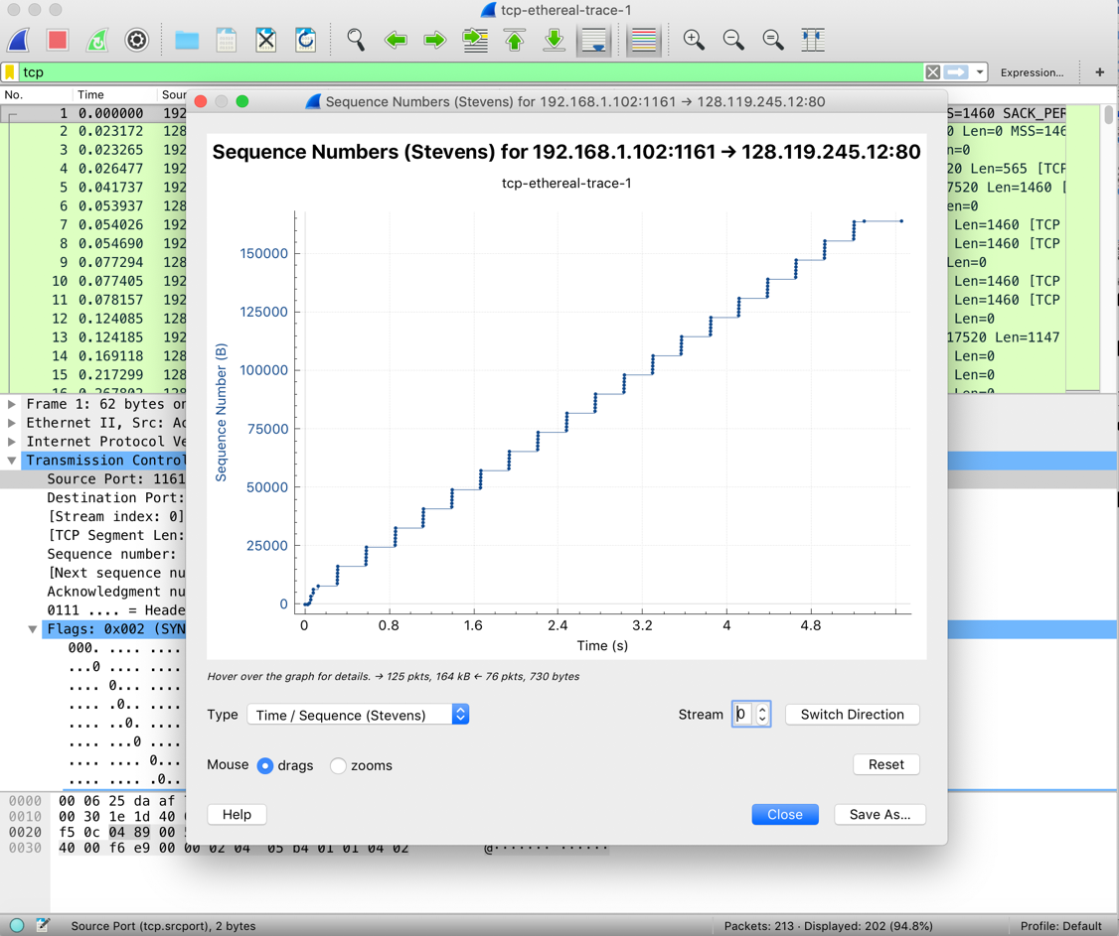

14. Answer Question 13 for the trace that you captured when you transferred a file from your own computer to gaia.cs.umass.edu

My Trace

We can see where TCP’s slowstart phase begins and ends; it quickly sends each part until there is a good congestion window, at which it then starts to send it in a predetermined sequence as ACKs are received. There’s a better view of the congestion window here. But comparing to the last question, windows are a lot bigger, and the “steps” of the sequences are bigger.

